  www.science-teachers.com |  | Name: __________________________
 |  |  |  | 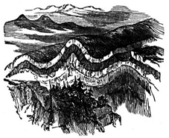  rock cycle  course-grained  erosion  extrusive  fine-grained  foliation  heat  intrusive  lava  magma  pressure
igneous  basalt  gabbro  obsidian  pumice  rhyolite | metamorphic  anthracite  gneiss  marble  schist  slate  soapstone  quartzite |  | sedimentary  chert  conglomerate  gypsum  limestone  sandstone  shale

